~Asia-China-Mirror-Han-Philospher and student and rampant animals

7in. dia., 780gm.

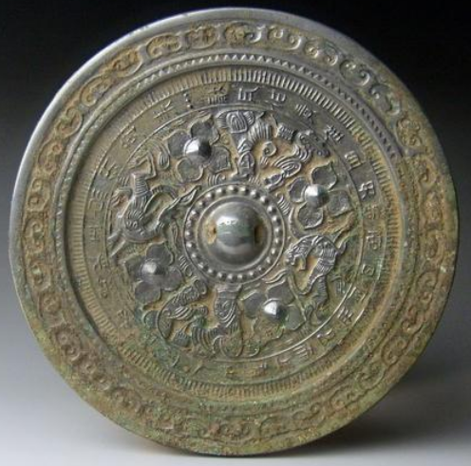

This unusual mirror show two views of a philosopher and a student separated by rampant animals, perhaps tigers. The theme suggests the pursuit of study amidst the flight of time as it runs continuously around the central boss. In the outer band is a lengthy poem relating to this theme. Around the rim of the mirror is a band of cloud lozenges and on the inner band is hachuring. It would appear that the philosopher is presenting the poem to the student, who looks attentively at his master.

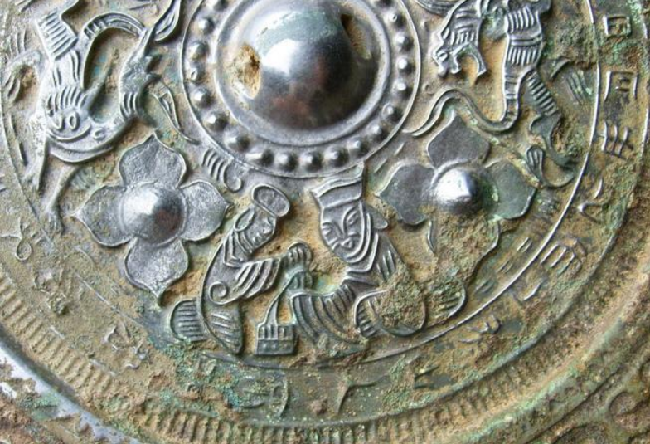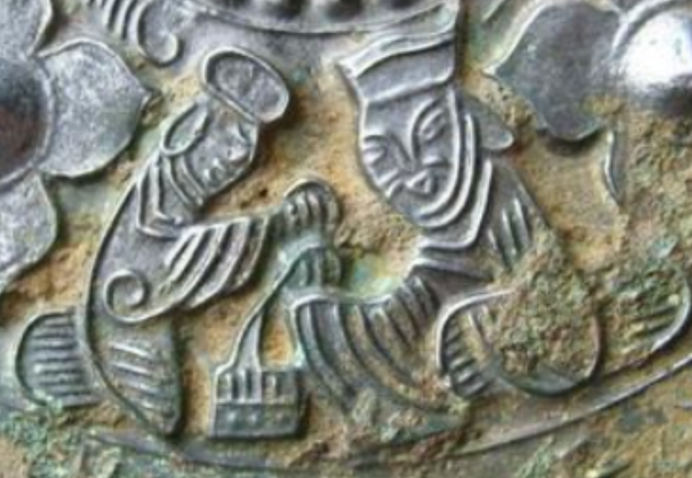

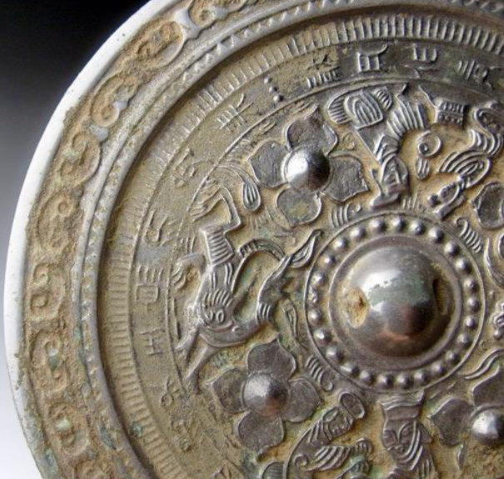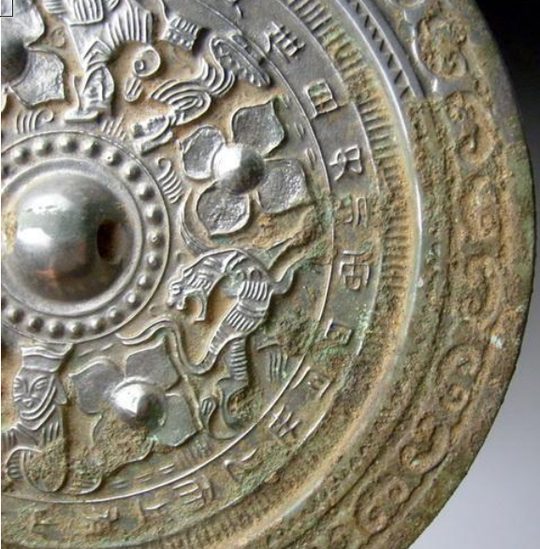

# Han Dynasty dragon&tiger grass inscriptions bronze mirror 7inch*780g